FINAL PROJECT
Diploma in Information Technology

2/26/2021
KHYber PAKHTUN KHWA TRADE TESTING BOARD PESHAWAR
STUDENTS GROUP NO 05 AT KHYBER COMPUTER & VOCATIONAL COLLEGE KHWAZA KHELA SWAT
TABLE OF CONTENT
E-COMMERCE WEBSITE
Name
“COMPUTER ONLINE”
Contents
Accomplished By: 3
Final Approval 4
DEDICTION 5
Preface 6
SELECTION 7
LANGUAGES USED IN THE PROJECT: 8
TOOLS 9
Home Page of the project/website 10
Coding of home page 12
THANK YOU 22

KHYBER COMPUTER & VOCATIONAL COLLEGE
Khwaza Khela Swat, 0946-745693

Accomplished By:
- Jawad Ahmad
- Shah Faisal
- Iftikhar Mian
- Shahid Ullah
- Bait ullah
- Muhammad Ajmal Khan
- Adnan Khan
- Ijaz Ali Khan
- Sana Ullah Khan
- Fayaz Ali
- Barkat Ali
- Abbas Khan
- Zia Uddin
- Sohail Khan

Under the kind supervision of:

Sir. Mudassir Khan

KHYBER COMPUTER & VOCATIONAL COLLEGE

Final Approval
- This is to certify that we have read this project report submitted by Jawad Ahmad
- Shah Faisal
- Iftikhar Mian
- Shahid Ullah
- Bait ullah
- Muhammad Ajmal Khan
- Adnan Khan
- Ijaz Ali Khan
- Sana Ullah Khan
- Fayaz Ali
- Barkat Ali
- Abbas Khan
- Zia Uddin
- Sohail Khan

is of high standard to warrant by Khyber Computer and Vocational College, Khwaza Khela Swat for Diploma in information Technology (DIT).

COMMITTEE:
External Examiner

Signature __________________________
Supervisor:
Sir. Mudassir Khan (M.Cs+DIT)
Signature __________________________

DEDICTION

This is effort is dedicated to almighty Allah, the most merciful and beneficent.

Sir. Mudassir Khan IT lecturer in Khyber Computer and Vocational College, Khwaza Khela Swat, our loving parents, who always wished a better future for us and provided us such opportunities through which this project seems to be completed,

Preface
This project is related to a website for online business or Freelancing.
All the parts of the property dealing are covered. We hope they will appreciate our work and the supervision of our teacher.

Sir. Mudassir Khan (M.Cs+DIT)
This project will provide such opportunities where their dealing task will be automated.

- Jawad Ahmad
- Shah Faisal
- Iftikhar Mian
- Shahid Ullah
- Bait ullah
- Muhammad Ajmal Khan
- Adnan Khan
- Ijaz Ali Khan
- Sana Ullah Khan
- Fayaz Ali
- Barkat Ali
- Abbas Khan
- Zia Uddin
- Sohail Khan

SELECTION

During the study of DIT usually all the student face the face the process of area selection, which was indeed a difficult decision for the student. Each of them get anxious which area should be selected.
We select to prepare a website on the name of “Computer Sahulat” for online computer services and we started the project.

We are thankful to all our honorable teacher of the Khyber Computer and Vocational institute especially Sir. Mudassir Khan and all the staff who provide us such environment with in which we completed our project successfully

- Jawad Ahmad
- Shah Faisal
- Iftikhar Mian
- Shahid Ullah
- Bait ullah
- Muhammad Ajmal Khan
- Adnan Khan
- Ijaz Ali Khan
- Sana Ullah Khan
- Fayaz Ali
- Barkat Ali
- Abbas Khan
- Zia Uddin
- Sohail Khan

LANGUAGES USED IN THE PROJECT:

HTML | Hypertext markup language
CSS | Cascading Style Sheet
SQL | Structured Query Language

TOOLS

Note Pad | Editor
Note Pad ++ | Editor
Sublime Text | Editor

Home Page of the project/website
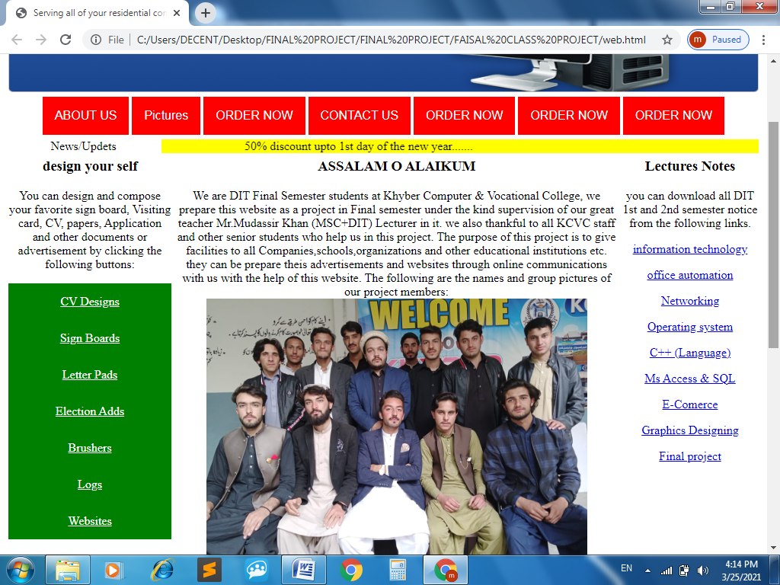

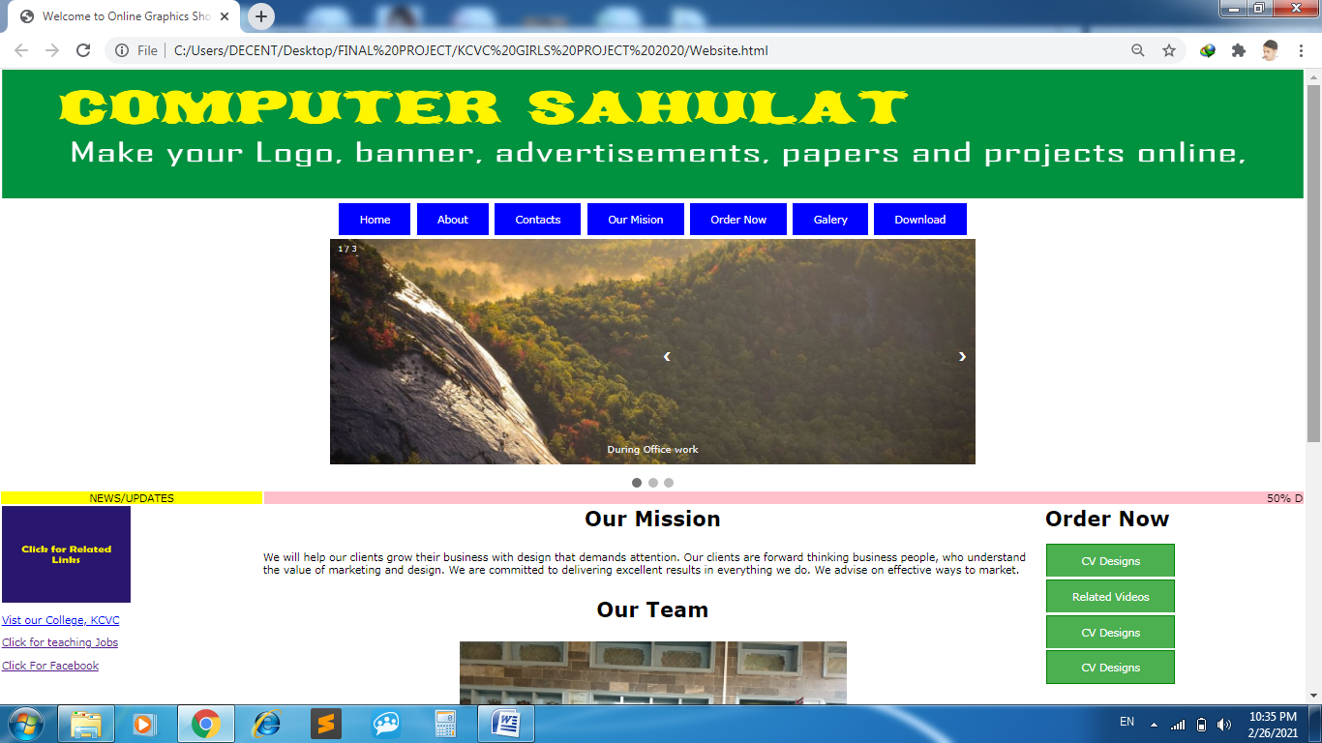

Coding of home page

<title> Welcome to Online Graphics Shop </title>

<table border="0" align="center" width="100%" height="200">
<tr>
<td align="center"> <img src="banner.jpg" width="100%" height="200"> </td>
</tr>

<table border="0" align="center" width="100%" height="40">
<tr>
<td align="center">
<style>
.button {
background-color:blue;
border: none;
color: white;
padding: 15px 32px;
text-align: center;
text-decoration: none;
display: inline-block;
font-size: 16px;
margin: 4px 2px;
cursor: pointer;
}
</style>
<a href="#" class="button">Home</a>
<a href="about.html" class="button">About</a>
<a href="Contact.html" class="button">Contacts</a>
<a href="Mission.html" class="button">Our Mision</a>
<a href="https://docs.google.com/forms/d/e/1FAIpQLScoFMtK7bRF8Go5b2pUcrMpHXia9BDqGZUsL-d7-qb0-Mlmfg/viewform?usp=pp_url" class="button">Order Now</a>
<a href="galery.html" class="button">Galery</a>
<a href="downloads.html" class="button">Download</a>

</td>
</tr>

<table border="0" align="center" width="100%" height="250">
<tr>
<td align="center"> <style>
* {box-sizing: border-box}
body {font-family: Verdana, sans-serif; margin:0}
.mySlides {display: none}
img {vertical-align: middle;}

/* Slideshow container */
.slideshow-container {
max-width: 1000px;
position: relative;
margin: auto;
}

/* Next & previous buttons */
.prev, .next {
cursor: pointer;
position: absolute;
top: 50%;
width: auto;
padding: 16px;
margin-top: -22px;
color: white;
font-weight: bold;
font-size: 18px;
transition: 0.6s ease;
border-radius: 0 3px 3px 0;
user-select: none;
}

/* Position the "next button" to the right */
.next {
right: 0;
border-radius: 3px 0 0 3px;
}

/* On hover, add a black background color with a little bit see-through */
.prev:hover, .next:hover {
background-color: rgba(0,0,0,0.8);
}

/* Caption text */
.text {
color: #f2f2f2;
font-size: 15px;
padding: 8px 12px;
position: absolute;
bottom: 8px;
width: 100%;
text-align: center;
}

/* Number text (1/3 etc) */
.numbertext {
color: #f2f2f2;
font-size: 12px;
padding: 8px 12px;
position: absolute;
top: 0;
}

/* The dots/bullets/indicators */
.dot {
cursor: pointer;
height: 15px;
width: 15px;
margin: 0 2px;
background-color: #bbb;
border-radius: 50%;
display: inline-block;
transition: background-color 0.6s ease;
}

.active, .dot:hover {
background-color: #717171;
}

/* Fading animation */
.fade {
-webkit-animation-name: fade;
-webkit-animation-duration: 1.5s;
animation-name: fade;
animation-duration: 1.5s;
}

@-webkit-keyframes fade {
from {opacity: .4}
to {opacity: 1}
}

@keyframes fade {
from {opacity: .4}
to {opacity: 1}
}

/* On smaller screens, decrease text size */
@media only screen and (max-width: 300px) {
.prev, .next,.text {font-size: 11px}
}
</style>
</head>
<body>

<div class="slideshow-container">

<div class="mySlides fade">
<div class="numbertext">1 / 3</div>
<img src="Slider1.jpg" style="width:100%">
<div class="text">During Office work</div>
</div>

<div class="mySlides fade">
<div class="numbertext">2 / 3</div>
<img src="slider2.jpg" style="width:100%">
<div class="text">Meeting Picture</div>
</div>

<div class="mySlides fade">
<div class="numbertext">3 / 3</div>
<img src="Slider3.jpg" style="width:100%">
<div class="text">Tour to Kalam</div>
</div>

<div class="mySlides fade">
<div class="numbertext">3 / 3</div>
<img src="Slider4.jpg" style="width:100%">
<div class="text">Tour to Lahore</div>
</div>

<a class="prev" onclick="plusSlides(-1)">&#10094;</a>
<a class="next" onclick="plusSlides(1)">&#10095;</a>

</div>
<br>

<div style="text-align:center">
<span class="dot" onclick="currentSlide(1)"></span>
<span class="dot" onclick="currentSlide(2)"></span>
<span class="dot" onclick="currentSlide(3)"></span>
</div>

<script>
var slideIndex = 1;
showSlides(slideIndex);

function plusSlides(n) {
showSlides(slideIndex += n);
}

function currentSlide(n) {
showSlides(slideIndex = n);
}

function showSlides(n) {
var i;
var slides = document.getElementsByClassName("mySlides");
var dots = document.getElementsByClassName("dot");
if (n > slides.length) {slideIndex = 1}
if (n < 1) {slideIndex = slides.length}
for (i = 0; i < slides.length; i++) {
slides[i].style.display = "none";
}
for (i = 0; i < dots.length; i++) {
dots[i].className = dots[i].className.replace(" active", "");
}
slides[slideIndex-1].style.display = "block";
dots[slideIndex-1].className += " active";
}
</script>

</body>
</html> </td>
</tr>

<table border="0" align="center" width="100%" height="20">
<tr>
<td align="center" width="20%" bgcolor="yellow"> NEWS/UPDATES </td>
<td align="center" width="80%"> <marquee bgcolor="pink"> 50% Discount on all Computer Sahulat Services... </td>
</tr>

<table border="0" align="center" width="100%" height="100%">
<tr>
<td valign="top" width="20%"> <img src="related.jpg" width="200" height="150" </p>
</p>
<a href="https://www.kcvc.edu.pk">Vist our College, KCVC</a> </p> </p>
<a href="https://www.nts.org.pk">Click for teaching Jobs</a> </p>
<a href="https://www.facebook.com">Click For Facebook</a>
</td>

<td valign="top" width="60%"> <h1> <b> <p align="center"> Our Mission </b> </p> </h1>
<p>We will help our clients grow their business with design that demands attention.
Our clients are forward thinking business people, who understand the value of marketing and design.
We are committed to delivering excellent results in everything we do.
We advise on effective ways to market. </p>
<h1>
<p align="center">
Our Team
</h1>
</p>
<p align="center">
<img src="group.jpeg" width="600">
</p>
<p align="center"> Yasmin, Amina, Marva, Mihnaz, Rooman, Meera </p>

</td>
<td valign="top" width="20%">
<style>
.btn-group .button {
background-color: #4CAF50; /* Green */
border: 1px solid green;
color: white;
padding: 15px 32px;
text-align: center;
text-decoration: none;
font-size: 16px;
cursor: pointer;
width: 200px;
display: block;
}

.btn-group .button:not(:last-child) {
border-bottom: none; /* Prevent double borders */
}

.btn-group .button:hover {
background-color: #3e8e41;
}
</style>
</head>
<body>

<div class="btn-group">
<p> <h1> <b> Order Now </h1> </b> </p>

<a href="cv.html" class="button">CV Designs</a>
<a href="videos.html" class="button">Related Videos</a>
<a href="#" class="button">CV Designs</a>
<a href="#" class="button">CV Designs</a>

</td>
</tr>

THANK YOU

